Welcome

THE PERFECT BALANCE OF FUNCTION AND STYLE

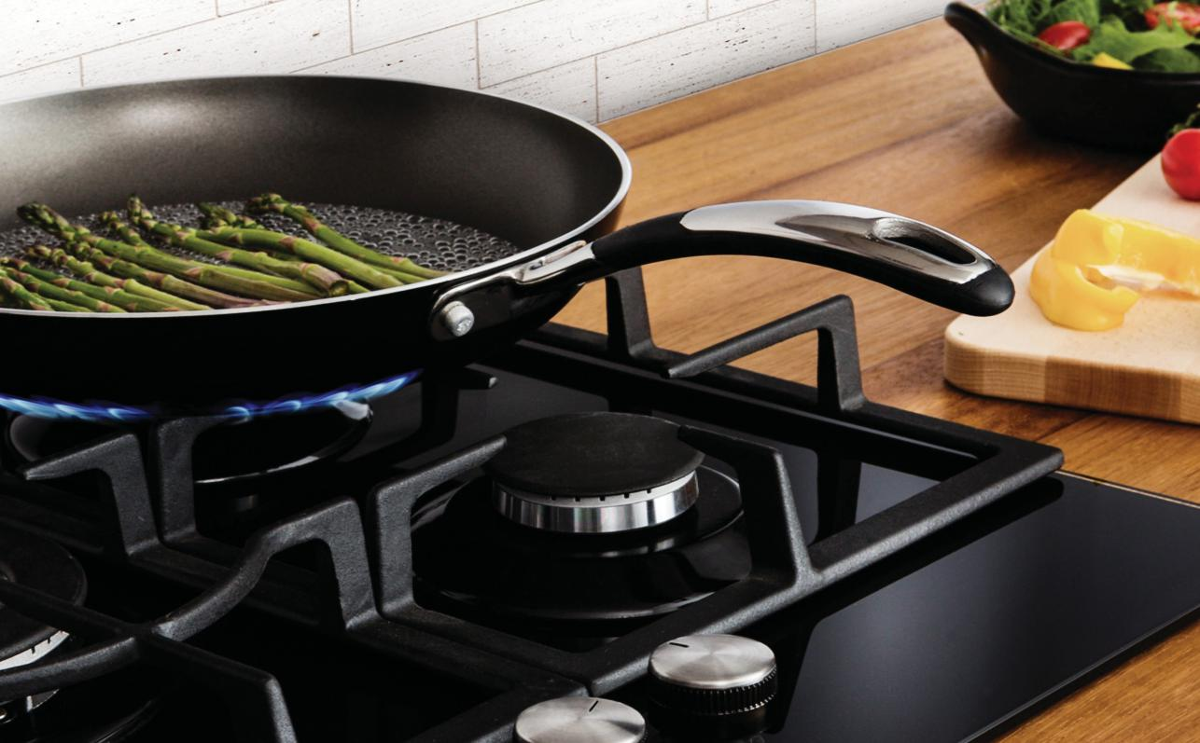LAUNDRY - DISHWASHING - COOKING - COOLING
Installation and Operating Instructions

Please read these instructions carefully before attempting to install or use this appliance. We recommend that you keep these instructions in a safe place for future reference.
Built in Warming Drawer
WD140BG - Black WD140ST - Stainless Steel
Thank you for choosing this Montpellier Built in Drawer.

Our Drawer has been designed to provide you with the best combination of style, reliability and performance to give you years of trouble-free use.

You may be familiar with a similar product, but please take time to read these instructions carefully before installing or using your Built in Drawer to ensure you get the most from your purchase.

We recommend that you keep this manual in a safe place for future reference.

Your Built in Warming Drawer is covered by a comprehensive two year Parts & Labour Guarantee. In the unlikely event that you experience a problem with your Drawer, you can rest assured that you are fully protected against the cost of repairs for the first

YEAR
GUARANTEE
PARTS & LABOUR

ACROSS ALL OUR MODELS

www.montpellier-appliances.com
24 months . Please note that any claim must be accompanied by the model reference number, serial number and proof of purchase.

To activate your guarantee, you will need your product serial number. This can be found on the rear of the machine.

There are two ways to register your Guarantee:

- Online: Visit the Support page on our website and complete the online Product Registration form. www.montpellier-appliances.com
- By Post: it in the post. Don’t forget to include your e-mail address so that we can send

Note: We are unable to take registrations over the phone.

6
8
8
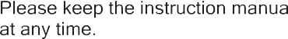Using your Warming Drawer 8
11
12

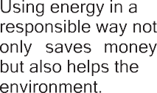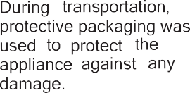Do not rest or sit on the drawer when open as this will damage the telescopic runners.
After unpacking, please dispose of all elements of the packaging in a way that will not cause harm to the environment.

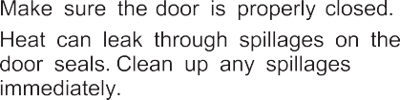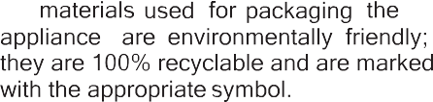

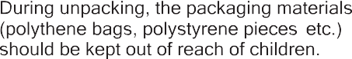

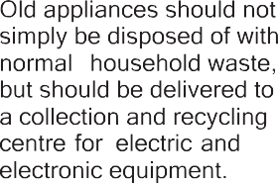

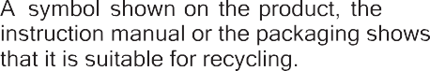

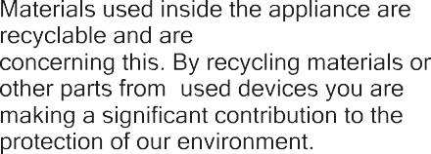
labelled with information

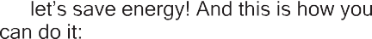centres for used devices can be provided

,

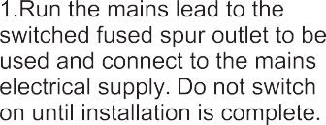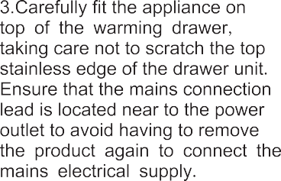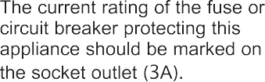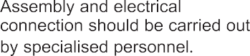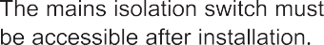
588

the warming drawer

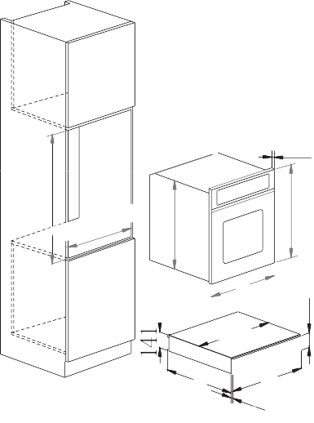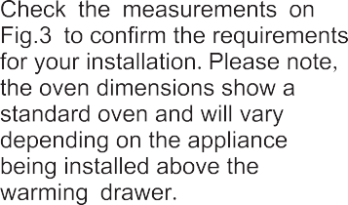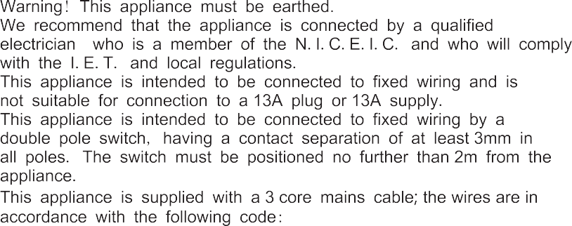Main lead behind the warming drawer must be placed in such manner to avoid touching the back panel of the appliance because of the heat it develops during operation.
19
432
455
595
132.5
555
560
595

21.5
8.5

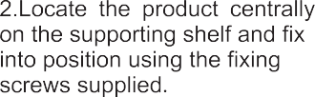
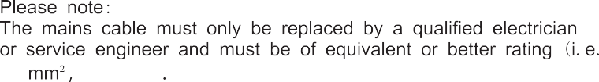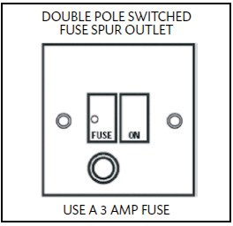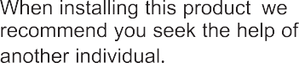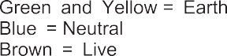
0.5
HO3VV-F)

Using the WARMING DRAWER

warming drawer

Place the dishes in the drawer.
  - Set the required temperature.
  - Press the power switch which will light up to confirm the warming drawer is switched on.
warming drawer
  - Close the drawer gently.
  - Switch the appliance off before removing the warmed dishes.

Selecting the Temperature
  - The temperature knob enables a temperature adjustment between approx. 40°C and 80°C.
  - Turn the temperature knob to the required position.
  - To prevent damage to the thermostat, do not force the temperature
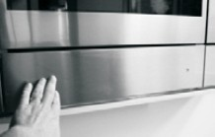knob past the maximum position.
  - 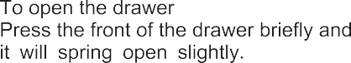The symbols do not indicate absolute temperature values but recommendations for optimum settings for cups and dishes.

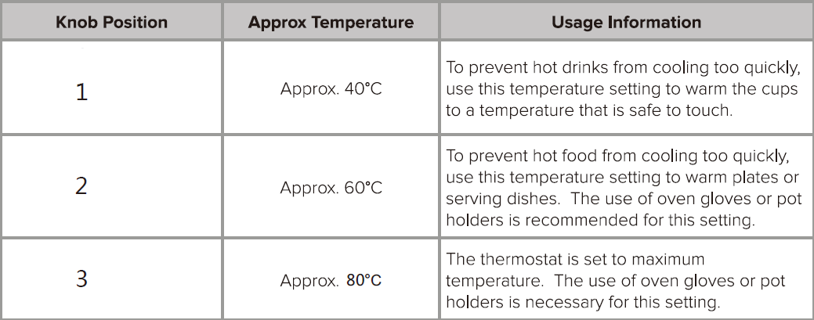
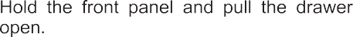
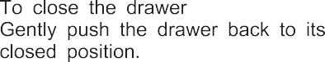
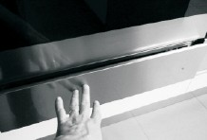

Warming Times

The time necessary for warming depends on various factors:
- Material and thickness of the dishes.
- Quantity of dishes to be warmed.
- Arrangement of dishes in the drawer.
- Temperature setting.

Therefore, exact warming times cannot be provided.
With use, experience will demonstrate optimal warming times and temperature settings.

Warming drawer capacity

The capacity of the warming drawer is 16kg.
The number of items this includes depends on the size and thickness of your crockery.
IMPORTANT:

- Always disconnect the appliance from the power supply before undertaking any cleaning.

- You should always allow the warming drawer to cool fully after use before undertaking any cleaning.

- Never use high pressure water or steam cleaners.

- Do not use detergents containing soda, acids or chlorides, abrasive detergents (in powder or lotion), abrasive sponges (e.g. steel wool) or sponges containing residuals of abrasive detergents, descaling detergents, dishwasher detergents or oven sprays.

Warming drawer exterior

- Clean with a damp cloth. If it is very dirty, add a few drops of dish washing detergent to the water. Dry with a dry cloth.

- Do not use corrosive or abrasive detergents as they can create dull areas. If any of these products accidentally come into contact with
the warming drawer, clean the appliance immediately with a damp cloth.

- Slight colour differences on the front of the appliance are due to the use of different materials such as glass, plastic and metal.

Front panel

- Use a mild detergent and a soft window cleaning cloth or a microfibre cloth that does not leave fibres on the surface. Wipe horizontally, without pressing.
- Do not use corrosive products, hard sponges or rough cloths for cleaning. Clean the aluminium surfaces with a dry cloth.

Glass base
- The glass drawer base can be lifted out to clean the bottom of the drawer. The base can be washed by hand with hot water and a mild detergent. Dry thoroughly.
Model | WD140BG WD140ST
Voltage rating | 220-240V~50Hz
power rating | 420W

- Refit the glass base in the drawer only when completely dry.

Drawer base

- It is advisable to clean the bottom of the drawer after every use, making sure to allow it to cool. This way, grime will not accumulate and cleaning is easier.
- Use a clean cloth, absorbent paper and washing up detergent or specific products for cleaning the vitroceramic top.
- It is advisable to periodically treat the vitroceramic with the special waxes available on the market.

PLEASE NOTE: Steam cleaners must not be used to clean this appliance.
Do not store flammable materials in the warming drawer .
Do not allow grease or food particles to build up around the door . IMPORTANT:
When correctly installed, your product meets all safety requirements laid down for this type of product. However , special care should be taken around the rear or the underneath of the appliance as these areas are not designed or intended to be touched and may contain sharp or rough edges that could cause injury.

Troubleshooting
If the dishes are not warm enough, make sure:
- the appliance is on.
- the right temperature has been set.
- the heat openings are not covered by large dishes .
- the dishes have been warmed for long enough.

Here For You

After-sales assistance

If you continue to experience problems with your Warming Drawer, please call the Montpellier customer service helpline on: 0 1759 487835.

Please have all your product details available, including the model number, serial number, date of purchase, and your retailer’s details before registering a fault.

The service call cannot progress without this information.

Your 2 year Manufacturer’s guarantee

THIS DOES NOT AFFECT YOUR STATUTORY RIGHTS.
Your new Montpellier appliance carries a free guarantee which protects you against the cost of repairs during the first 24 months from date of purchase provided that:
Any claim is accompanied by evidence of the model reference, model serial number and proof of purchase, such as a Sales Receipt, showing that the appliance was purchased within the 24 months prior to the date
of claim.

What is not covered under the Guarantee
- Any appliance not correctly installed and operated in accordance with the manufacturer’s instructions.
Here For You
- Any appliance that is used for anything other than domestic purposes.
- Any defect caused by accident, misuse, unauthorised modification or inexpert repair.
- Cost of Call-out where a fault cannot be found with the appliance.
- Cost of Call-out for work covering routine maintenance, such as, but not exclusively, cleaning of filters or defrosting.
- Cost of Call-out for work required to correct the alignment of doors following door reversal procedures carried out by you.
- Use of the appliance by anyone other than the Householder.
- Use in any commercial environment.
- Consumable items, such as, but not exclusively, fuses in plugs, bulbs and breakable items which require routine replacement.
- Repair costs incurred that have not been authorised by Montpellier and/or carried out by a non-approved Montpellier engineer.

YOUR GUARANTEE IS VALID ONLY IN THE UK & ROI.
T
alternatively, you can register online at www.montpellier-appliances.com/support

SERVICE HELP-LINE

Should your appliance develop a fault, please call the Montpellier customer service helpline on: 01759 487835.

Please remember to have all your product details available, including the model number, serial number, date of purchase and your retailer’s details before registering a fault.

Montpellier Domestic Appliances Ltd.
Unit 1, Tewkesbury Retail Park, Northway Lane, Tewkesbury, Gloucestershire. GL20 8JU.

www.montpellier-appliances.com

Your service call cannot progress without this information. The symbol on the product or on its packaging indicates that this product may not be treated as household waste. Instead it shall be handed over to the applicable collection point for the recycling of electrical and electronic equipment. By ensuring this product is disposed of correctly, you will help prevent potential negative consequences for the environment and human health, which could otherwise be caused by inappropriate waste handling of this product. For more detailed information about recycling of this product,

