BUILT-IN ELECTRIC HOB
INSTALLATION AND OPERATION MANUAL
SP601X
Please read the instruction manual carefully before operating your new hob.
Dear Owner: Thank you for purchasing our cooktop which is designed to give you many years of
cooking pleasure. Before using your new appliance please read the user's manual carefully and
keep it in a safe place for future reference.

THIS APPLIANCE MUST BE INSTALLED ONLY BY A QUALIFIED PERSON IN
INSTRUCTIONS PROVIDED. THE MANUFACTURER DECLINE ALL RESPONSIBILITY FOR
IMPROPER INSTALLATION WHICH MAY HARM PERSONS AND ANIMALS OR CAUSE
DAMAGE TO PROPERTY. THE APPLIANCE MUST BE USED ONLY FOR THE PURPOSE
FOR WHICH IT WAS EXPRESSLY DESIGNED. ANY OTHER USE (e.g. HEATING ROOMS) IS
CONSIDERED TO BE IMPROPER AND MANUFACTURER DECLINES ALL RESPONSIBILITY
FOR DAMAGE RESULTING FROM IMPROPER AND IRRESPONSIBLE USE.

SAFETY WARNING
1. Please check the built-in electric hob's integrity after opening the package. If there
are any problems please refer to the supplier.
2. Do not throw the package materials (plastic bag, foam, nails, package etc) in a
place where children can easily access. Please dispose of packaging in an
environmentally friendly manner.
3. Do not change the wiring under any circumstances.
4. Dispose of the appliance in an environmentally friendly manner.
5. If the supply cord is damaged,it must be replaced by the manufacturer its service
agent or similarly qualified persons in order to avoid a hazard.
6. This appliance can be used by children aged from 8 years and above and persons
with reduced physical, sensory or mental capabilities or lack of experience and
knowledge if they have been given supervision or instruction concerning use of the
appliance in a safe way and understand the hazards involved
7. Children should be supervised to ensure that they do not play with the
appliance. Cleaning and user maintenance shall not be made by children without
supervision.
8. Do not stare at the hob elements when the appliance is working.
9. Accessible parts may become hot during use. To avoid burns young children should
be kept away
10. WARNING: If the surface is cracked, switch off the appliance to avoid the
possibility of electric shock, for hob surfaces of glass-ceramic or similar material which
protect live parts
11.Shall state a steam cleaner is not be used.
12.Metallic objects such as knives, forks, spoons and lids should not be placed on the
hob surface since they can get hot.
13.CAUTION: The surface temperature exceeds 95°C.To avoid a hazard,under bench
access must be restricted.Refer to the installation instructions.
14.WARNING: The appliance and its accessible parts become hot during use. Care
should be taken to avoid touching heating elements.Children less than 8 years of age
shall be kept away unless continuously supervised.
15.The appliance is not intended to be operated by means of an external timer or
separate remote-control system.
16.WARNING: Unattended cooking on a hob with fat or oil can be dangerous and
may result in fire. NEVER try to extinguish a fire with water, but switch off the
appliance and then cover flame e.g. with a lid or a fire blanket.
17.WARNING: Danger of fire: do not store items on the cooking surfaces.
18.CAUTION: The cooking process has to be supervised. A short term cooking
process has to be supervised continuously.
19.WARNING: Use only hob guards designed by the manufacturer of the cooking
appliance or indicated by the manufacturer of the appliance in the instructions for use
as suitable or hob guards incorporated in the appliance. The use of inappropriate
guards can cause accidents.

A duplicate data label and wiring diagram are contained in this booklet.Please attach these labels
to an accessible and near by surface for easy reference. The Manufacturer shall not be held
responsible for any innaccuracies in this handbook due to printing or transcription errors,also the
designs in the figures are purely indicative. The Manufacturer also reserves the right to make any
modifications to the products as may be considered necessary or useful also in the interests of
the user, without jeopardizing the main functional and safety features of the products themselves.

Description of the hot plates
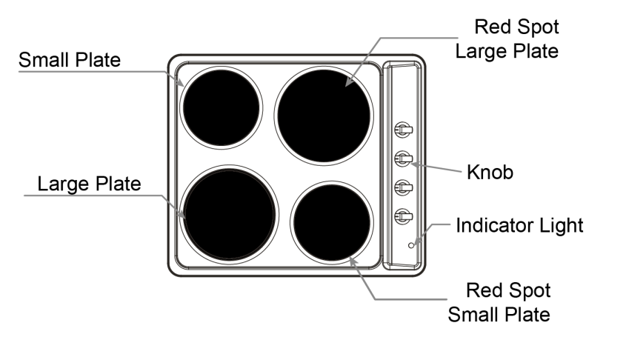
Use
Directions for Use
1. Do not touch the appliance with wet hands.
2. Do not operate the appliance when barefoot.
3. Do not allow children to operate the hob.
4. Please disconnect the power supply before any maintenance and cleaning.
5. Electric hobs become and remain hot during and immediately after use. Do not touch the hob
until it has been allowed to cool.
6. Steam cleaners must not be used to clean the appliance.
7. The appliance is not intended to be operated by means of an external timer or separate
remote-control system.
8. The power supply should use H05VV-F.
9. The hob must be built into a heat-resistant cabinet. Smoke may be visible when first used – this is normal. Please leave on for a few minutes to burn off excess sealant.
Operation
The temperature of the hot plates can be adjusted by turning the knobs either clockwise or
anti-clockwise to any of the 6 positions besides the 0 position (Off). The higher the number, the
greater the output of heat (see table below). The indicator light is a signal that the electric plates
are switched on.
The level of heat can be adjusted gradually by turning the appropriate knob to the right or left.
The indicator light can be found on the control panel – please see above diagrams.
HEAT  SETTING | DESCRIPTION
0 | OFF position
1 | VERY GENTLE - warming up
2 | GENTLE - stewing vegetables,  slow cooking
3 | SLOW - cooking soups, larger dishes
4 | MEDIUM - slow frying
5 | HIGH - grilling meat, fish
6 | VERY HIGH - grilling meat, fish
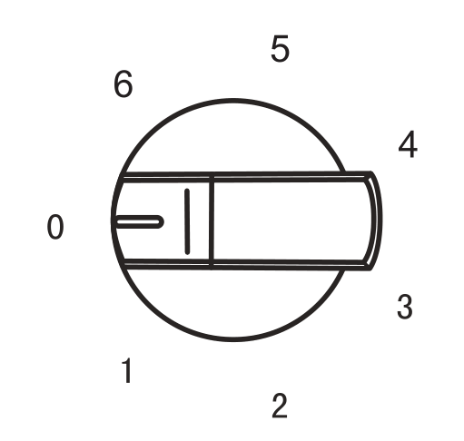

An appropriately sized pan saves energy.
The correct pan should have a thick, flat base, with a diameter equal to the plate diameter,
so that heat is transferred more efficiently.
Advice on the Use of Electric Plates
To save energy and ensure longer life of the electric plates, we advise using pans with a flat
bottom and with a diameter no less than the diameter of the plates.
Never leave the plates on without pans on them, or with empty pans and never use the
plates to heat crockery. Switch on the plates after having set the pans on them.
Do not touch the hob until it has been allowed to cool as the plates remain hot for a short
period of time after being switched off.
Switch off the heating plate before removing the pans.

Technical Data
Model | Power Supply | Electric Plate Power(W) |  |  |  | Size | Built-in Hole Size
 |  | 145mm | 145mm  (Red) | 180mm | 180mm  (Red)
SP601X | AC220-240V  50Hz | 1000 | 1500 | 1500 | 2000 | 580X500X78 | 557(L)X477(W)

Pans
- Use pans with flat bottoms. Uneven or thin bottoms will waste energy and are slow to
cook.
- Smaller pans will waste energy.
- Do not use oversized pans. More than 50mm overhang can cause components to
overheat and cause fine cracks in enamel or even damage heating elements.
- Use only dry pans. Do not place wet or condensated items (eg. lids) on the hotplates.
- Do not use pots and pans that are unsteady and likely to rock or overturn.
- Do not operate the hob for an extended time without a pan on the hotplate.
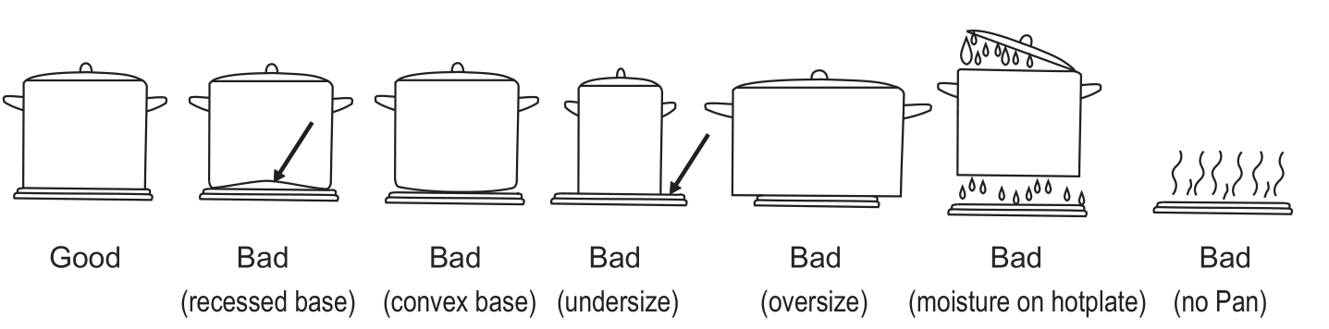
CLEANING
The appliance must be turned off at the mains before carrying out any maintenance. Make
sure the hob plates are not hot prior to any cleaning or maintenance. Any abrasive cleaners
(such as Cif) will scratch the surface and could erase the control panel markings. Stainless
steel can be effectively cleaned by simply using a dilute solution of water and washing up
liquid and drying to a shine with a clean cloth. Over time with use, the stainless steel surface
may discolour – this is normal and does not constitute a fault with this appliance. Proprietary
stainless steel cleaners are available.
HOTPLATE CARE
The finish of the cast iron hotplates is designed to be durable in use. The following tips
should be observed to get the best from your hob:
1. Do not use decorative covers as these can cause damage to the surface and lead to rust.
2. Use a special hotplate surface cleaner to protect and restore the surface of the hotplates.
3. Do not use soap and water on the hotplates. Wipe up spills and splashes immediately.
4. Never operate the hob without a pan, unless it is for a few seconds (as below).
5. Deposits of fat can be burned off by turning the hotplate on for a few seconds. The fat will
brush off when the appliance has cooled down.
TECHNICAL INFORMATION FOR INSTALLATION (Qualified Personnel Only)
Electrical Connection
Appliances with three-pole cables are set up for operation with alternating current at the
voltage and frequency indicated on the rating plate. Please ensure you have studied and are
familiar with the connection wiring diagram provided prior to installation. Note that the earth
conductor is yellow/green. The connection to the electricity supply must be made by a
qualified person and following the regulations in force. When the appliance is to be installed
above a built-in oven, the two appliances must be connected separately.
The supply cable must be so positioned that no point can reach a temperature 50° C higher
than the ambient temperature. Also check that the supply system has an effective earth
connection and corresponds to the standards in force and that the plug (or omnipolar switch)
can be reached easily when the appliance is installed.

Fitting Guidelines
The voltage rating of the hob heating elements is 220-240V. Adapting the hob to operate
with one-phase current is possible by appropriate bridging in the connection box according to
the connection diagram below. The connection diagram is also shown on the cover of the
connection box. Remember that the connection wire should match the connection type and
the power rating of the hob.
The connection cable must be secured in a strain-Relief clamp.
CONNECTION DIAGRAM  Caution! Voltage of heating elements 220-240V  Caution! In the event of any connection the safety  wire must be connected to the E terminal. | 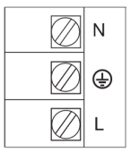 | Recommended  type of  connection  lead
 | 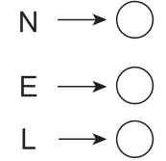
• If the cable is damaged or to be replaced, the operation must be carried out the by
after-sale agent with dedicated tools to avoid any accidents.
• If the appliance is being connected directly to the mains an omnipolar circuit-breaker must
be installed with a minimum opening of 3mm between contacts.
• The installer must ensure that the correct electrical connection has been made and that it
is compliant with safety regulations.
• The cable must not be bent or compressed.
• The cable must be checked regularly and replaced by authorised technicians only.

Caution!
Remember to connect the safety circuit to the connection box terminal marked withThe electricity supply for the hob must have a safety switch which enables the power to becut off in case of emergency. The distance between the working contacts of the safety switch must be at least 3 mm. Before connecting the cooker to the power supply it is
important to read the information on the data plate and the connection diagram.
The manufacturer will not accept any responsibility if the applicable standards are
not respected.
This appliance myst be installed only by authorised personnel and in accordance
with UK regulations. The surfaces must be capable of sustaining temperatures of
80°C. All laminates, fixing adhesive and surface materials should be certified suitable
for this temperature.
According to the diagrams below, cut a hole in the worktop and insert the hob. The
hob can be fitted to any worktop with a thickness of 40mm or 50mm.
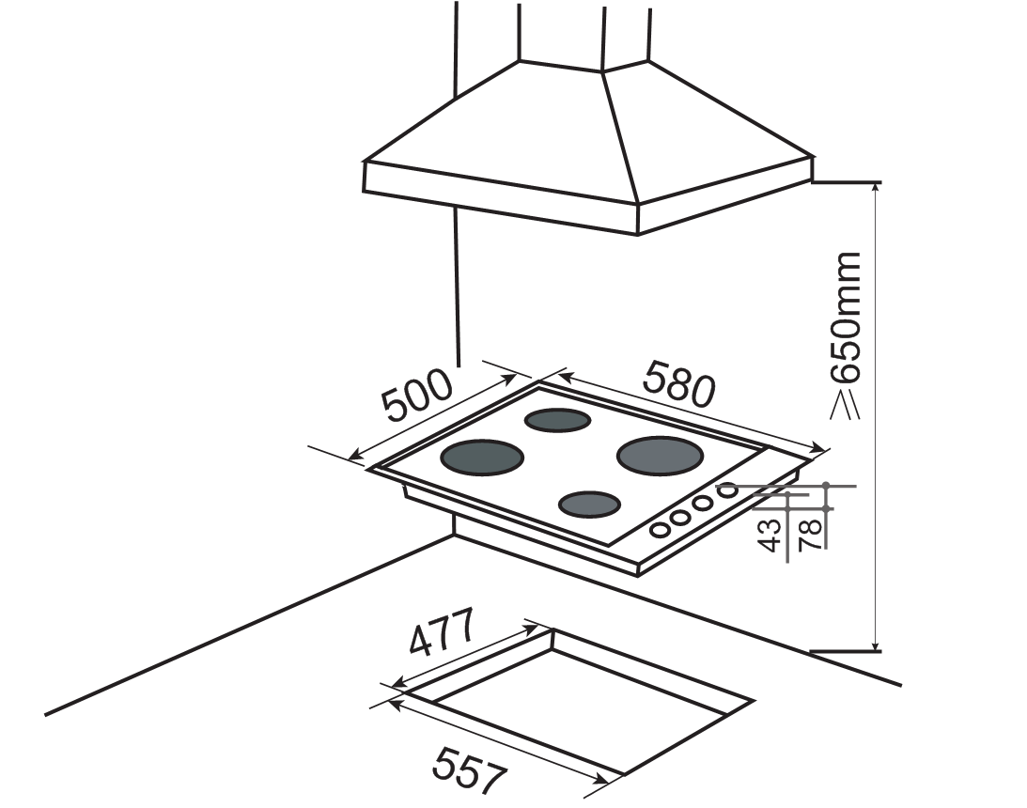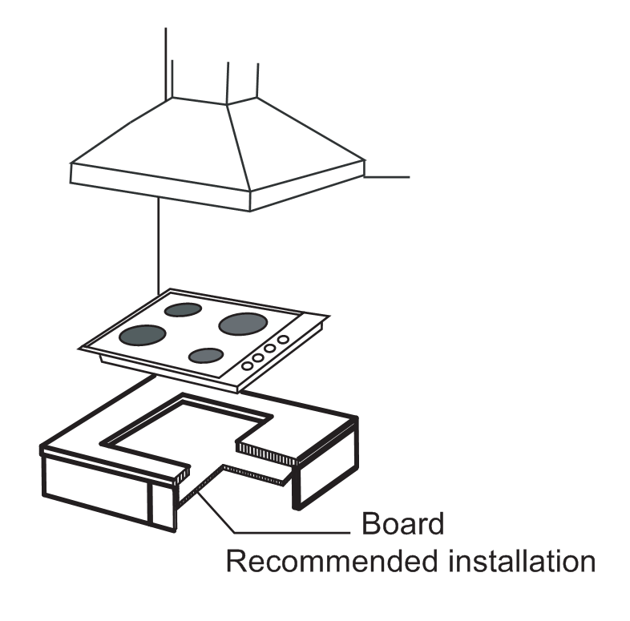

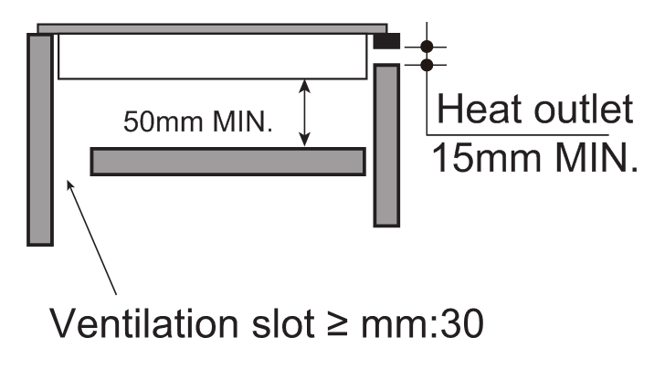
Please note the following:
1. The minimum height of any adjacent units (including light pelmets) is 450mm,
unless they are manufactured from a material resistant to fire (ceramic tiles, for
example).
2. No overhang or cooker hood is permitted within 650mm distance in height above the
hotplates.
3. Leave at least 50mm clearance between the underside of the appliance and any
combustible area.
INSERTING AND FIXING THE HOB
Before inserting the hob into the work surface, place the adhesive seal (a) around
the underside edge of the hob. It is important to fix this seal evenly without gaps or overlapping
to prevent liquids from seeping underneath the hob. Please follow the below instructions:
1) Place the seal around the bottom edge of the hob as shown in the illustration below.
2) Place the hob in the installation opening and push it down so that the hob is resting firmly
on the worktop.
3) Secure the hob in position using the fixing brackets supplied.
Screw one end of the bracket into the pre-drilled holes in the underside of the hob.
The other end of the bracket should be located underneath the worktop to secure the hob in position.
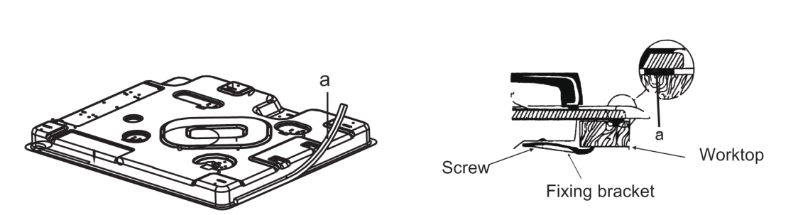
TROUBLESHOOTING
PROBLEM | CHECKLIST
Hob does not work | •Check the wiring connection  •Check the fuse and voltage
Smoke when hob is on | •This is normal on first use  •Clean area around hotplates
Damaged wire | •Contact service provider and do not attempt  to use

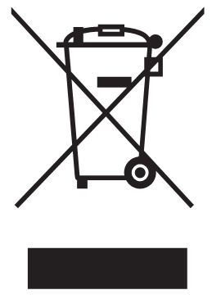 | This appliance is labelled in compliance with European directive 2012/19/EC for Waste Electrical and Electronic Equipment (WEEE). By ensuring that this appliance is disposed of correctly, you will help prevent any possible harm to the environment and to human health which might otherwise be caused if disposed of in the wrong way.  The symbol on the product indicates that it may not be treated as normal household waste.  It should be taken to a collection point for the recycling of electrical and electronic goods.  This appliance requires specialist waste disposal. For further information regarding the treatment, recovery and recycling of this product, please contact your local council, household waste disposal service or the shop where you purchased the product.  For more detailed information about treatment, recovery and recycling of this product, please contact your local local council, household waste disposal service or the shop where you purchased the product.

TECHNICAL INFORMATION
About Erp
 | Symbol | Value | Unit
Model identification | -- | SP601X
Type of hob | -- | Built-in hob
Number of electric cooking zones and/or areas | -- | 4
Heating technology (induction cooking zones and cooking  areas, radiant cooking zones, solid plates) | -- | Solid plates
For circular cooking zones or area: diameter of useful surface area per electric heated cooking zone, rounded to the nearest 5 mm | Ø | FL: 18,0  FR: 14,5  RR: 18,0  RL: 14,5 | cm
For non-circular cooking zones or  areas: length and width of useful  surface area per electric heated  cooking zone or area, rounded to  the nearest 5 mm | L, W | N/A | cm
Energy consumption per cooking  zone or area calculated per kg | EC electric cooking | FL: 199  RR: 194  FR: 205  RL: 184 | Wh/kg
Energy consumption for the hob calculated per kg | EC electric hob | 195 | Wh/kg

